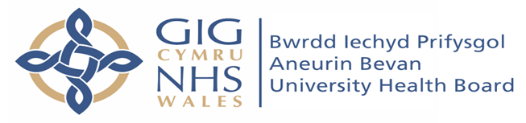


Salaried GP Advert for 5 Sessions @ Malpas Brook Health Centre
(with option of sessions @ HMP Usk & Prescoed)

To support flexible working amongst our current staff we are looking for an enthusiastic GP to provide 5 sessions and join our friendly and supportive primary care team. We are a highly motivated well-organised training practice that prides ourselves on providing high quality patient centred care whilst maintaining a good work life balance.

The surgery is situated directly off Junction 26, M4 - an easy commute from both Cardiff and Bristol.

The Practice
- 3 GP Partners, 5 Salaried doctors and 2 GP registrars
- List size: 11,000
- Hold GMS contract for providing GP services each morning at HMP Usk & HMP Prescoed
- High QOF / QAIF achievers Paper light practice using Emis Web
- Excellent nursing and administrative support
- Practice Pharmacists, Nurse Practitioner with independent prescribing qualifications
- Minor illness nurse and full nursing team
- Varity of enhanced services including minor surgery and contraceptive IUD and Implants
- Final year medical student teaching

The Job
- Pay negotiable depending on experience and skills but from £11,500k per session
- 5 Sessions ideally all day Wednesday and Friday plus Thursday Morning
- Equal workload between doctors
- Daily lunch catch up
- You will be fully supported by our existing clinicians and practice management team in a culture where CPD/training and personal development are encouraged.

Start date: Negotiable but ideally May 2026
For further information or informal visit, please contact our practice manager
Mrs Kerry Hagland Tel: 01633 855808 Mob: 07402652425 Email: kerry.hagland@wales.nhs.uk
Or senior partner Dr Rebecca Moore @ rebecca.moore@wales.nhs.uk

