Redlands Surgery
Vacancy for a Salaried GP
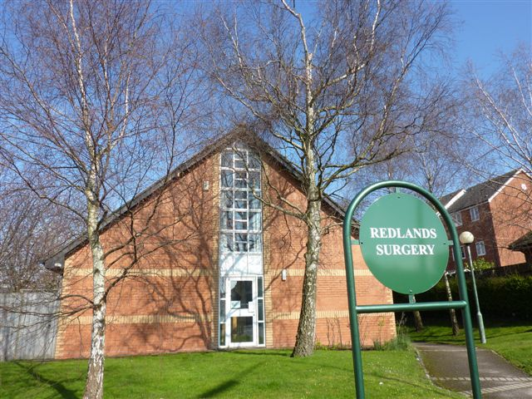
We are excited to be advertising for a new salaried GP position with a view to partnership in the future at our fantastic practice in Penarth. The successful candidate would be joining a very motivated and friendly team, providing care to approximately 9500 patients in the Eastern Vale cluster.

The Role:
We are looking for a GP to cover 5 sessions over 3 days with a proportionate on call.
The successful applicant may be newly qualified or very experienced, all we ask from the right candidate is that they are driven, enthusiastic and with a vision of how they see primary care moving forward in the coming years. Special interests welcome, particularly chronic diseases, or happy with helping to develop special interest areas.

Who we are:
We are a very enthusiastic and well-managed and organised practice, established within the Eastern Vale Cluster (EVC) of Cardiff & Vale University Health Board. Currently we have a list size of circa 9,500. One of our partners is a Vale Constituency member for the Bro Taf LMC. We provide a full range of enhanced services to our patients.

We currently have 3 partners, 4 salaried GP’s, 2 nurses and 2 healthcare support workers. We have an ambition to become a training practice.

What we can offer you:
A competitive salary, 8 weeks annual leave including any sessions that you would normally work on a bank holiday and 1 week study leave.
Peer support and mentoring to further develop your clinical skills and interests.

A warm welcome awaits you at Redlands Surgery. Informal discussions are welcomed by contacting the Practice Business Manager Carl Lloyd on 02920 713950 carl.lloyd2@wales.nhs.uk or the senior partner Fran Ferner on fran.ferner@wales.nhs.uk

Applications by CV and covering letter to Carl Lloyd via e-mail carl.lloyd2@wales.nhs.uk

